Sequences Overview (Strings, Lists, Tuples)
- Strings are immutable sequences of characters. You can index (s[0], s[-1]) and slice (s[1:4], s[:]) strings, but not modify them in place. All operations that appear to change a string actually create a new string.
- Lists are mutable sequences of any type. Use indexing and slicing similarly, but you can also change elements (lst[i] = x), append (lst.append(x)), or remove items. Lists have many methods (append, extend, pop, etc.), and built-in functions like len(lst) or the function sorted(lst) operate on lists.
- Tuples are immutable sequences, often used for fixed collections or record-like structures. A tuple literal is written with commas, e.g. (1, 2) or just 1, 2 (parentheses are optional on the left side of assignment). Tuples do not support item assignment or methods like .append(). They are often used as dictionary keys (because they are hashable).
Each sequence type supports iteration: for x in some_sequence: works for strings, lists, or tuples alike.

Iterating and Range
- A for loop can iterate over any sequence. Example:
- for ch in "Hello":
print(ch)
- The range() function produces a sequence of integers (e.g. range(5) gives 0,1,2,3,4). It’s commonly used as for i in range(5): ....
- You can use len(), min(), max(), and sum() on sequences (and any iterable) to compute these values.

List Methods vs Built-in Functions
- List methods modify the list in place. For example, lst.append(x) adds an element to lst. The method lst.sort() sorts the list but returns None. It sorts in-place (the list itself is changed) .
- Built-in functions often create new lists or values. For example, sorted(lst) returns a new sorted list, leaving lst unchanged. Similarly, len(lst) and sum(lst) compute values without altering the list.
- Key difference: Use lst.sort() when you want to modify the original list (and don’t need a return value). Use sorted(lst) if you need to keep the original list and get a new sorted list (but note it uses more memory since it makes a copy) .
Operation | Effect | Returns | Example
lst.sort() | Sorts list in place (ascending by default) | None | lst.sort(); print(lst) sorts lst.
sorted(lst) | Returns a new sorted list | new sorted list | new = sorted(lst); print(new)
lst.append(x) | Adds x to end of lst | None | lst.append(3)
len(lst) | Number of elements | integer | len([1,2,3]) → 3

Tuples and Tuple Comparison
- Tuples are compared lexicographically, element by element, using the first unequal elements to determine order.
- Example: (0, 1, 2) < (0, 3, 4) is True because the first elements (0 and 0) are equal and the second elements (1 and 3) determine the result (1 < 3. Even if later elements differ, they are not considered once a difference is found. For instance, (0, 1, 2000000) < (0, 3, 4) is also True because the second element 1 < 3, and the huge third element is ignored.
- When sorting a list of tuples, Python uses this same rule: it sorts by the first element of each tuple, then by the second if the first are tied, and so on.
print((0, 1, 2) < (0, 3, 4)) # True
print((0, 1, 2000000) < (0, 3, 4)) # True
Output:
True
True

Tuple Assignment & Unpacking
Tuple (and sequence) unpacking allows multiple variables to be assigned in one statement:
m = ('have', 'fun')
x, y = m
print(x) # have
print(y) # fun
- Parentheses are optional on the left: x, y = m works same as (x, y) = m.
- Swapping variables: A common trick is a, b = b, a, which swaps the values of a and b in one line. All expressions on the right are evaluated before assignment.
- Mismatch error: The number of variables on the left must match the number of values on the right. For example, a, b = 1, 2, 3 raises a ValueError: too many values to unpack.
- Unpacking with split(): You can unpack results of functions that return sequences. For instance, splitting an email address:
- addr = '[email protected]'
uname, domain = addr.split('@')
print(uname) # monty
print(domain) # python.org
Here split('@') returns a list ['monty', 'python.org'], whose two elements are unpacked into uname and domain.
a = 5; b = 10
a, b = b, a # swap
print(a, b) # 10 5
Output:
10 5

Decorate–Sort–Undecorate (DSU) Pattern
DSU (Decorate–Sort–Undecorate) is a pattern for custom sorting. You decorate each item by attaching a sort key, sort the resulting list of tuples, then undecorate (strip away the extra keys). In Python:
- Decorate: Build a list of tuples where each tuple is (sort_key, original_item) or vice versa, depending on the sort order needed.
- Sort: Sort the list of tuples (possibly with reverse=True) – Python sorts by the first element of each tuple (and then second, etc.).
- Undecorate: Extract the original items from the sorted tuple list.
Example: sort words by length (longest first):
txt = 'but soft what light in yonder window breaks'
words = txt.split()
t = []
for word in words:
t.append((len(word), word)) # decorate with length
t.sort(reverse=True) # sort by length descending
res = []
for length, word in t:
res.append(word) # undecorate
print(res)
Output:
['yonder', 'window', 'breaks', 'light', 'what', 'soft', 'but', 'in']
Explanation: Each tuple (len(word), word) is sorted by length, and ties are broken by the word lexicographically. This code is straightforward because Python's tuple comparison handles the keys automatically.

Converting Dictionaries to Lists of Tuples
Dictionaries have an items() method that returns a list of (key, value) tuples. For example:
d = {'b': 1, 'a': 10, 'c': 22}
t = list(d.items())
print(t)
Output:
[('b', 1), ('a', 10), ('c', 22)]
This list t is not sorted by keys; it reflects the dictionary’s internal order. Since lists of tuples are sortable, you can sort t to order by keys:
t.sort()
print(t)
Output:
[('a', 10), ('b', 1), ('c', 22)]
(Now the list is sorted by key alphabetically.)
To sort a dictionary by value, use DSU: build (value, key) tuples, sort them, then iterate:
l = []
for key, val in d.items():
l.append((val, key))
l.sort(reverse=True)
print(l)
Output:
[(22, 'c'), (10, 'a'), (1, 'b')]
(We sorted by value descending. By placing val first in each tuple, the sort used the value as the primary key.)
In practice, the “undecorated” output (just the keys) can be obtained by iterating over the sorted tuple list with unpacking:
for val, key in l:
print(key, val)

Word Frequency Example
The following example reads a text file and finds the top 10 most common words. It demonstrates cleaning text, counting with a dictionary, and using DSU to sort by frequency:
import string
fhand = open('romeo-full.txt')
counts = dict()
for line in fhand:
line = line.translate(str.maketrans('', '', string.punctuation))
line = line.lower()
words = line.split()
for word in words:
if word not in counts:
counts[word] = 1
else:
counts[word] += 1
lst = []
for key, val in counts.items():
lst.append((val, key))
lst.sort(reverse=True)
for count, word in lst[:10]:
print(word, count)
Explanation:
- str.maketrans('', '', string.punctuation) creates a translation table to remove all punctuation characters. line.translate(...) strips punctuation (so “hello!” → “hello”).
- line.lower() converts text to lowercase (so “The” and “the” count as the same word).
- split() breaks the line into words.
- We update a dictionary counts mapping each word to its occurrence count.
- Then we use DSU: we create a list of (count, word) tuples, sort it descending, and print the first 10 tuples. Because count is first in the tuple, the sort is by frequency; ties are broken alphabetically by the word.
Running this on romeo-full.txt yields:
i 61
and 42
romeo 40
to 34
the 34
thou 32
juliet 32
that 30
my 29
thee 24
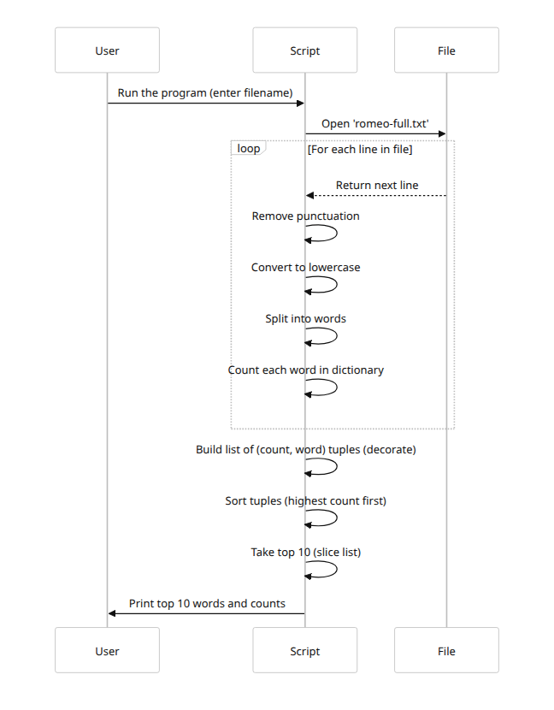

Common Pitfalls & Best Practices
- Shadowing built-ins: Do not use names like list, str, dict, etc. as variable names. For example, list = [1,2,3] prevents you from using the list() constructor or methods; it also causes errors if you try to call list() later. Instead use descriptive names (words, items, etc.).
- list.sort() vs sorted(): Remember that lst.sort() sorts in-place and returns None, whereas sorted(lst) returns a new sorted list . Do not write new_list = lst.sort(), as this will set new_list to None. Use lst.sort() by itself or use new_list = sorted(lst).
- Matching unpack counts: When unpacking, ensure the number of variables matches the number of elements. A mismatch (too many or too few) raises a ValueError.
- Immutable vs mutable: Tuples are immutable. You cannot append or remove elements from a tuple (t.append(x) on a tuple would error). Lists are mutable and have methods like .append(), .pop(), .remove(), etc. Use tuples when you need a fixed collection or a dictionary key.
- Consistent types when sorting: All items in a list must be mutually comparable when sorting. For example, a list of strings can be sorted, but a list mixing strings and integers will raise a TypeError.

